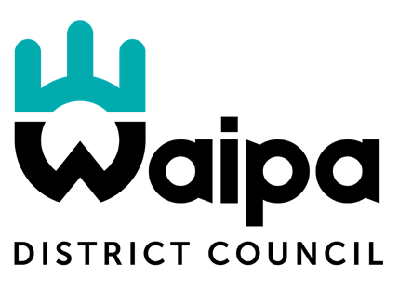

14th January 2020

Cogswell Survey 5 Milicich Place P O Box 156 CAMBRIDGE

Dear Pete McLachlan and Alistair Bond

CAMBRIDGE PUMP TRACK

Postal Address
Private Bag 2402
Te Awamutu 3840 New Zealand

Head Office
07 872 0030
101 Bank Street
Te Awamutu 3800

Cambridge Office
07 823 3800
23 Wilson Street
Cambridge 3434

0800 WAIPADC (924 723)
www.waipadc.govt.nz
/WaipaDistrictCouncil
/Waipa_NZ
/Waipa_DC
Waipā District Council would like to express our appreciation for the work Cogswell Surveys completed on the Cambridge Pump Track Community Project.

Cogswell Survey was called upon with very short notice to complete ‘as built’ plans for the track and stormwater drainage. From the onset, Cogswell were extremely cooperative, easy to work with and happy to assist with technical knowledge and flexibility to complete the work in a very timely manner.

Waipā District Council look forward to working with Cogswell on other projects in the future.

Yours sincerely
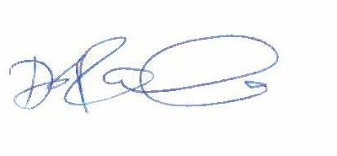

Debbie Lascelles

GROUP MANAGER STRATEGY AND COMMUNITY SERVICES

